

Read before you Tag

Make sure you have an Allflex Red Total Tagger or the New Allflex

UTT3S ( others do not work)

<https://www.allflex.global/na/utt3s/>

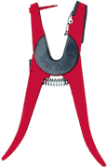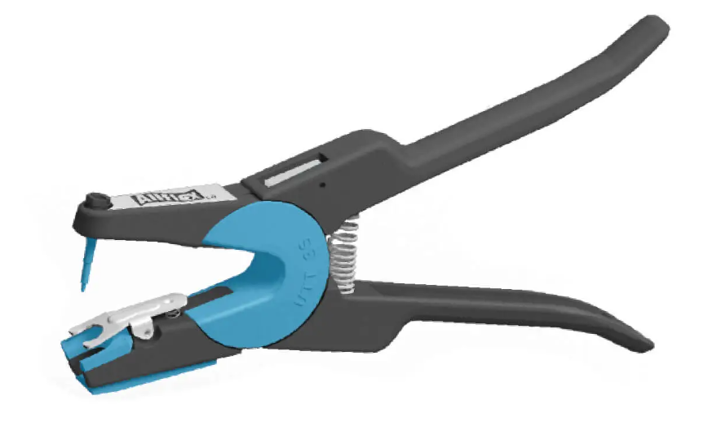

Take the Black clip out to apply the Allflex Cattle EID tag.

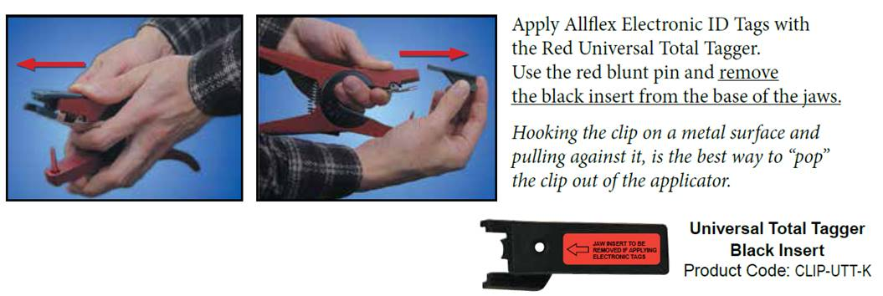

You can also take another applicator and stick the pin through the hole in the clip and pull the clip out.

Tired of infected and swelled ears?

Remember to disinfect the male stem before application to reduce infection. Spray the male stem with Chlorahexidine/water or a residual wound/heal spray

EID tag **should be on the inside** of the ear. Panel tag is on the back side of the ear.

Check out the video on stock show tag application!

<https://youtu.be/NH_oq0zF8RE>